**DESIGN AND IMPLEMENTATION OF AN ORDER REVIEW E-COMMERCE SYSTEM WITH PAYMENT ON DELIVERY SUPPORT**

BY

**OKEREKE** CHIMEMEZIEM DANIEL

BU/23A/IT/8106

The Faculty of Computing & Applied Sciences

BAZE UNIVERSITY

ABUJA

SEPTEMBER, 2025

**DESIGN AND IMPLEMENTATION OF AN ORDER REVIEW E-COMMERCE SYSTEM WITH PAYMENT ON DELIVERY SUPPORT**

Thesis Submitted in Partial Fulfillment of the Requirement for the Degree of

B. Sc.

In

Computer Science [INFORMATION SYSTEM MANAGEMENT]

By

**OKEREKE** CHIMEMEZIEM DANIEL

To

*The Faculty of Computing & Applied Sciences*

Baze University, Abuja

SEPTEMBER, 2025

**DECLARATION**

This is to certify that this project entitled **Design And Implementation Of An Order Review E-Commerce System With Payment On Delivery Support**, which is submitted by **Okereke Chimemeziem Daniel** in partial fulfilment of the requirement for the award of degree for B.Sc. in Information System Management to the Department of Computer Science, Baze University Abuja, Nigeria, comprises of only my original work and due acknowledgement has been made in the text to all other materials used.

Date: 09/ 2025 Okereke Chimemeziem Daniel:

**APPROVED BY** ……………………………

**Head**

Department of Computer Science

**CERTIFICATION**

This is to certify that this project entitled **Design And Implementation Of An Order Review E-Commerce System With Payment On Delivery Support**, which is submitted by **Okereke Chimemeziem Daniel** in partial fulfilment of the requirement for the award of degree for B.Sc. in Information Technology to the Department of Computer Science, Baze University Abuja, Nigeria is a record of the candidate’s own work carried out by the candidate under my/our supervision. The matter embodied in this project is original and has not been submitted for the award of any other degree.

Date: Supervisor: Dr. Usman Bello Abubakar

**APPROVAL**

This is to certify that the research work, **Design And Implementation Of An Order Review E-Commerce System With Payment On Delivery Support** and the subsequent preparation by **Okereke Chimemeziem Daniel** with **BU/23A/IT/8106** has been approved by the Department of Computer Science, Faculty of Computing and Applied Science, Baze University, Abuja, Nigeria.

By

Dr Usman Bello Abubakar Date/Sign

Supervisor

Dr Abubakar Idris Usman Date/Sign

Head, Department of Compuer Sciences

Prof Rufai Aliyu Yauri Date/Sign

Dean, Faculty of Computing and Applied Science

External Examiner Date/Sign

**DEDICATION**

I dedicate this work to my family and amazing friends for their constant support. To the faculty staff of Information Technology, Dr Usman Bello Abubakar, Dr Abubakar Idris Usman, Mr. Tijanni Abdullahi, Prof. Peter Ogedebe, Dr Noah Akande, Dr Charles Isah Saidu, to name a few. This project is a testament to their unwavering support, guidance, and wisdom. Lastly, to all fellow enthusiasts who believe technology can be used to improve human lives.

**ABSTRACT**

[The abstract provides a clear summary of the project, indicating both content and tone of the project. An abstract includes the method(s) used to analyze the problem, a brief description of the research design, a listing of the key results, a brief description of the significance of the results, selected key conclusions. First-person narrative should not be used in the abstract.]

# TABLE OF CONTENT

**DECLARATION** 3

**CERTIFICATION** 4

**APPROVAL** 5

**DEDICATION** 6

**TABLE OF CONTENT** 8

**LIST OF TABLES** 11

**LIST OF FIGURES** 12

**LIST OF ABBREVIATION** 13

**CHAPTER 1: INTRODUCTION** 2

1.1 Overview 2

1.2 Background and Motivation 4

1.2.1 Background 4

1.2.2 Motivation 4

1.3 Statement of the Problem 6

1.4 Aims and Objectives 7

1.4.1 Aim 7

1.4.2 Objectives 7

1.5 Significance of the Project 8

1.6 Project Risks Assessment 9

1.7.1 Scope 10

1.7.2 Project Organization 10

**CHAPTER 2: LITERATURE REVIEW** 12

2.1 Introduction 12

2.2 Historical Overview 13

2.3 Related Work 16

2.4 Summary 18

**CHAPTER 3: REQUIREMENTS, ANALYSIS, AND DESIGN** 19

3.1 Overview 19

3.2 Proposed Model 20

3.3 Methodology 21

3.3.1 Date Gathering Method 21

3.4 Tools and Techniques 23

3.5 Ethical Consideration 25

3.6 Requirements Specifications 26

3.6.1 Functional Requirements Specifications 26

3.6.2 Non-Functional Requirement Specifications 27

3.6.3 System Requirements Specifications 28

3.7 System Design 30

3.7.1 Application Diagram 30

3.7.2 Use case diagram 31

3.7.3 Entity-Relationship Diagram (ERD) 33

3.7.4 Data Design 34

3.7.5 Activity Diagrams 36

3.7.6 Data Flow Diagram 37

3.7.7 Control Flow Diagram 37

3.7.8 User Interface Design 39

3.9 Summary 42

**CHAPTER 4: TESTING AND IMPLEMENTATION** 43

4.1 Overview 43

4.2 Main Features 44

4.3 Implementation Problems 53

4.4 Overcoming Implementation Problems 54

4.5 Testing 55

4.5.1 Test Plans (For Unit, Integration and System Testing) 55

4.6 Use Guide 60

4.6.2 User Guide 60

4.7 Summary 63

**CHAPTER 5: DISCUSSION, CONCLUSION, AND RECOMMENDATIONS** 64

5.1 Overview 64

5.2 Objective Assessment 65

5.3 Limitations and Challenges 66

5.4 Future Enhancements 67

5.5 Recommendations 68

5.6 Summary 69

**REFERENCES** 70

**Appendix A - Project Document** 73

Background and Motivation 73

Statement of the Problem 74

**Appendix B – Model Training and Data Collection** 75

**Appendix C- Source Codes** 80

**LIST OF TABLES**

TABLE 1.1 *PROJECT RISK ASSESSMENT*

TABLE 3.1 *FUNCTIONAL REQUIREMENTS*

TABLE 3.2 *NON-FUNCTIONAL REQUIREMENTS*

TABLE 3.3 *SOFTWARE REQUIREMENTS*

TABLE 3.4 *HARDWARE REQUIREMENTS*

**LIST OF FIGURES**

FIGURE 3.1 - *APPLICATION DIAGRAM OF THE USER VIEW*

FIGURE 3.2 - *APPLICATION DIAGRAM OF THE ADMIN VIEW*

FIGURE 3.3 – *USE CASE DIAGRAM*

FIGURE 3.4 – *ERD (ENTITY-RELATIONSHIP DIAGRAM) DIAGRAM*

FIGURE 3.5 – *ACTIVITY DIAGRAM SHOWING HOW THE USER WOULD INTERACT WITH THE SYSTEM*

FIGURE 3.6 - *DATA FLOW DIAGRAM*

FIGURE 3.7 – *USER CONTROL FLOW DIAGRAM*

**CHAPTER ONE**

**INTRODUCTION**

* 1. Overview

E-commerce (Electronic commerce) means a business conducted using the internet (Jain, V., 2021). E-commerce aids clients to be able to buy goods and services using internet technologies and its related structure by providing a market place deprived of a physical restraint and without physical interaction (Odunola, 2013). Customers and merchants are not visible to one another, but can all be participating in the same market place at the same time and with an estimate of over two billion people connected to the internet (Miniwatts Marketing Group, 2011), the reach of an e-commerce service is huge.

E-commerce has revolutionized global trade by enabling transactions over the internet, eliminating geographical and physical barriers (Rayport, J. F., & Jaworski, B. J. 2003). However, in markets like Nigeria, where cash transactions dominate and trust in digital payments is low, traditional prepaid e-commerce models face significant challenges. This project focuses on the design and implementation of an order review e-commerce system with payment on delivery (POD) support, addressing the unique needs of cash-reliant consumers while enhancing trust and reducing fraud risks.

However, according to certain unverified news sources, POD is thought to be a commonly used payment mechanism in Nigeria for transactions between consumers and online merchants. In Nigeria, POS and ATM machines typically accept debit and credit cards for cash withdrawals. The payment process is made more difficult by the fact that many bank cards do not enable payments on e-commerce websites at all, or if they do, they require prior activation before a transaction can be made using phone banking.

1.2 Background And Motivation

1.2.1 Background

The Nigerian e-commerce sector has experienced rapid growth, driven by increasing internet penetration from 1% in 2000 to 29.5% in recent years. Despite this growth, adoption of digital payments remains low, with over 80% of transactions still cash-based. Early e-commerce platforms in Nigeria struggled due to consumer doubt about online payments, , and delivery reliability.

Nigerian consumers lack the technological know-how necessary for internet purchasing because the majority of the population lives in rural regions and the country has a very low literacy rate. Customers are also less trusting when it comes to disclosing their e-payment details online. As a result, POD is seen as a preferred option for internet purchasing. Customers that choose the POD payment option choose to pay for the item after it is delivered.

Customers that choose POD can make purchases without using cash. A logistics firm is enlisted to deliver the goods and collect payment once the retailer sends out an invoice along with the shipment. As a result, this strategy gives the client confidence and security.

The introduction of Pay on Delivery (POD) by pioneers like Jumia.com.ng marked a turning point, enabling customers to inspect products before payment. This model significantly boosted e-commerce activity by aligning with local preferences for cash transactions and mitigating trust barriers. However, challenges such as order fraud, high return rates, and logistical inefficiencies persist, necessitating a more robust system integrating order review mechanisms with POD.

1.2.2 Motivation

This project is motivated by the dominance of cash transactions in Nigeria and similar markets. Low trust in prepaid e-commerce due to fears of fraud, late deliveries, and substandard products. The success of POD models in increasing conversion rates but lacking advanced features like real-time order review. The need for fraud-resistant systems to reduce losses for merchants.

By combining order review functionalities with POD, this system aims to enhance transparency, reduce disagreements, and improve operational efficiency for e-commerce platforms.

1.3 Statement Of The Problem

Online payments, often known as e-payments, are made, received, and processed electronically over the Internet. E-commerce transactions can be made using a variety of mobile-enabled payment methods, such as credit cards, prepaid cards, smart cards, e-cash (digital currency), and e-checks (digital checks). Although credit cards are the most widely used electronic payment method worldwide (Kou, 2013), previous studies have shown that POD is one of the most popular e-commerce payment methods in countries like Malaysia, China, India, and the United Arab Emirates.

Current e-commerce systems in cash-reliant markets face critical issues such as high return rates where customers cannot modify orders after checkout, leading to mismatched expectations, fraud risks: due to dishonest buyers refuse payment upon delivery, causing revenue loss, and operational inefficiencies: as manual verification of POD orders increases costs and delays. Therefore, to improve e-commerce, cash on delivery is the most popular choice among consumers. (Amobi, 2023; Sasu, 2022; Fastercapital, 2023).

This project addresses these gaps by introducing an intermediate order review stage and automated fraud detection to streamline POD transactions.

1.4 Aims And Objectives

1.4.1 Aim

To design and implement an Order Review E-Commerce System with POD support, improving customer trust, reducing fraud, and optimizing logistics for cash-based transactions.

1.4.2 Objectives

1. Todevelop an order review interface that allow customers to confirm or modify orders before delivery.
2. To enhance delivery tracking by providing real-time updates on order status and payment collection.
3. To improve backend efficiency through automating order verification and reducing manual overhead.

1.5 Significance Of The Project

The significance of this project is rooted in its direct response to the key economic and social barriers hindering the growth of e-commerce in cash-reliant economies such as Nigeria. The proposed system offers a practical solution that provides tangible benefits to businesses, consumers, and the broader digital ecosystem.

For merchants, the system holds significant economic and operational value. By requiring customers to confirm their purchase intent before dispatch, it directly mitigates the high financial losses associated with fraudulent orders and failed deliveries. Furthermore, it improves operational efficiency by automating the order verification process, which reduces the need for manual confirmation calls and enables faster, more accurate order fulfillment.

From the consumer's perspective, the project's primary significance lies in its ability to build trust and confidence. Allowing customers to review and modify orders before shipment directly addresses the widespread fear of receiving incorrect or substandard products. This transparency creates a more user-centric and reliable purchasing journey, leading to higher customer satisfaction and encouraging repeat business from a previously skeptical user base.

On a broader scale, this project serves as a functional blueprint for adapting e-commerce technology to other emerging markets that face similar challenges of low digital payment adoption and trust deficits. Academically, it offers a valuable case study on localizing information systems, providing a foundation for future research into developing more robust and culturally relevant e-commerce solutions.

1.6 Project Risks Assessment

Table 1.1 *Project Risk Assessment*

|  |  |  |
| --- | --- | --- |
| **RISK** | **RISK MITIGATION** | **IMPACT** |
| Low User Adoption | Implementing a user-centric and intuitive design to accommodate users with varying technical know-how. | High |
| Security Breaches | Using robust security measures like HTTPS, data encryption, and secure authentication to protect sensitive user data and build trust. | High |
| Technical Implementation Issues | Adopting a modular three-tier architecture and conducting thorough unit, integration, and system testing to ensure stability | Medium |
| Scope Creep | Maintaining a clearly defined project scope that outlines all included and excluded features to prevent project delays and budget overruns | Medium |

1.7 Scope/Project Organization

1.7.1 Scope

This project covers:

1. Frontend Development: User interfaces for order review, payment selection, and delivery tracking.
2. Backend Systems: Secure databases for order management, fraud detection algorithms, and logistics coordination.
3. POD Workflow: Processes for delivery confirmation, cash collection, and receipt generation.
4. Security Measures: Encryption, OTP verification, and AI-based fraud prevention.

1.7.2 Project Organization

This project focuses on the *design and implementation of a complete e-commerce system* tailored for markets with a preference for Payment on Delivery (POD).. The scope is defined by the following core functional areas:

1. **Frontend Development**: This includes creating a responsive and user-friendly interface using *React.js, HTML, and CSS* technologies. Key user-facing features within the scope are interfaces for order review and modification, payment selection, and real-time delivery tracking.
2. **Backend Systems**: The scope covers the development of a secure backend using *PHP and Laravel as the framework.* This involves creating secure databases for managing users, products, and orders; implementing business logic for the POD workflow; and developing fraud detection algorithms.
3. **POD Workflow**: The project scope includes the entire POD process, from a customer placing an order to delivery confirmation, the logistics of cash collection, and final receipt generation.
4. **Security Measures**: Implementing essential security features is a core part of the scope. This includes using HTTPS for secure communication, applying AES encryption for sensitive data like passwords, and integrating OTP verification to enhance user and transaction security.

This project is specifically focused on the POD model. Therefore, the integration of **third-party payment gateways for prepaid transactions is explicitly excluded** from the scope.

1.7.2 Project Organization

This thesis is organized into **five chapters**, each detailing a specific phase of the project's lifecycle.

1. **CHAPTER ONE:** Introduction.

* Objective: To establish the context, justification, and scope of the project.
* Activities: Defining the project's background and motivation , formulating the statement of the problem , outlining the specific aims and objectives , and assessing project risks.

1. **CHAPTER TWO:** Literature Review

* Objective: To review existing academic literature relevant to e-commerce, payment systems, and user trust.
* Activities: Providing a historical overview of e-commerce , analyzing related work on POD systems , and summarizing key findings from existing research.

1. **CHAPTER THREE:** Requirements, Analysis, And Design

* Objective: To specify the system's requirements and create a detailed architectural blueprint.
* Activities: Defining the proposed system model , gathering requirements , specifying functional and non-functional requirements , and creating system design diagrams like Use Cases, ERDs, and Data Flow Diagrams.

1. **CHAPTER FOUR:** Testing And Implementation

* Objective: To build, test, and document the functional e-commerce system based on the design specifications.
* Activities: Implementing the main features of the application , documenting and overcoming implementation problems , and executing comprehensive test plans for unit, integration, and system testing.

1. **CHAPTER FIVE:** Discussion, Conclusion, And Recommendations

* Objective: To evaluate the project's outcomes, summarize the findings, and propose directions for future work.
* Activities: Assessing the project against its initial objectives , discussing the limitations and challenges faced , and providing recommendations for future enhancements

1.8 Swot Analysis

This SWOT analysis evaluates the internal *Strengths* and Weaknesses of the project, along with the external *Opportunities* and *Threats* it faces within the Nigerian e-commerce market.

Strengths:

* Addresses a Core Market Need: The system is specifically designed to solve the widespread lack of trust in digital payments and online transactions in Nigeria.
* Enhanced Consumer Trust: The order review functionality is a key strength that empowers customers to confirm orders before dispatch, directly increasing their confidence and security.

Weaknesses:

* Excludes Digital Payments: By design, the project excludes third-party payment gateways for prepaid transactions. This may limit its appeal to a growing segment of users who are comfortable with and prefer digital payments.
* Dependence on Logistics Partners: The success of the POD model is heavily reliant on the efficiency and integrity of external logistics companies for delivery and payment collection. Any failure on their part directly impacts the system's reliability.

Opportunities:

* High Preference for POD: The continued dominance of cash transactions and strong consumer preference for POD create a significant market opportunity for a system that refines and secures this payment method.
* Building on Existing Systems' Flaws: The system can capitalize on the trust deficit and logistical inefficiencies faced by current e-commerce platforms, offering a more secure and transparent alternative.

Threats

* Intense Competition: The project faces stiff competition from established e-commerce giants in Nigeria like Jumia and Konga, which already have significant market share and brand recognition.
* Evolving Payment Habits: As digital infrastructure improves and consumer trust in online payments grows, the demand for POD could decrease over time, potentially reducing the long-term competitive advantage of the system.
* Economic Instability: Broader economic factors in Nigeria, such as inflation or recession, could negatively impact consumer spending and the operational viability of both merchants and logistics partners.

1.9 Definition Of Terms

This section defines the key terms and acronyms used throughout the thesis to ensure clarity and understanding.

* E-commerce: Short for Electronic Commerce, it refers to any business or commercial transaction that is conducted using the internet.
* Payment on Delivery (POD): A payment method where a customer pays for goods at the time of delivery rather than in advance. In this document, it is used interchangeably with *Cash on Delivery (COD).*
* Order Review System: A core feature of the proposed project that provides an interface for customers to confirm or modify the details of their order *before* it is dispatched for delivery.
* Frontend: This refers to the presentation layer of the application, which is the part the user directly interacts with. It includes the user interface (UI) and all visual elements.
* Backend: This refers to the server-side of the application, which is not visible to the user. It is responsible for managing the core business logic, processing data, and handling database interactions.
* Three-Tier Architecture: A system design model that separates an application into three distinct logical layers: the presentation layer (frontend), the application layer (backend logic), and the database layer (data storage).
* Database: An organized collection of structured information, or data, typically stored electronically. In this project, it is used to manage information on users, products, orders, and payments.

**CHAPTER TWO: LITERATURE REVIEW**

2.1 Introduction

Electronic commerce (e-commerce) has fundamentally altered the landscape of global retail, moving beyond its initial conception as a mere digital catalogue to become an integral component of multi-channel business strategies aimed at increasing market reach and profitability. As noted by Bakar et al. (2025), modern e-commerce is not simply about performing traditional business functions in a new medium; it involves a fundamental re-engineering of entire business processes to capitalize on the unique efficiencies of the digital marketplace. The core premise of e-commerce is the leveraging of the internet to conduct business with greater efficiency and effectiveness, offering consumers direct, controlled access to a company's systems. This allows for the personalization of goods and services and ensures their timely delivery, generating significant financial benefits through increased revenue and reduced operational costs (Nasution & Surya, 2025).

The explosive growth of e-commerce has been a global phenomenon, yet its adoption and manifestation vary significantly across different economic and cultural contexts. While developed economies have seen a swift and widespread adoption of digital payment systems—such as credit cards, bank transfers, and mobile wallets—many developing nations continue to grapple with a unique set of challenges that temper this transition. In these markets, a significant portion of the population remains reliant on traditional, non-digital transaction methods. This is particularly true in Nigeria, where a persistent "trust deficit" in online systems, coupled with infrastructural limitations, has shaped a distinct e-commerce ecosystem.

It is within this context that the Payment on Delivery (POD) model—often used interchangeably with Cash on Delivery (COD)—has emerged not merely as an alternative payment option, but as a critical enabler of e-commerce itself. POD allows consumers to defer payment until the physical receipt and inspection of goods, thereby mitigating the perceived risks of online fraud, non-delivery, or the delivery of substandard products. This payment method effectively bridges the gap between the digital storefront and the tangible, trust-based world of traditional commerce. As Vandiny et al. (2022) observe, in regions with underdeveloped digital infrastructure or low consumer confidence in online security, POD has been an indispensable catalyst for market growth.

This chapter provides a comprehensive review of the existing literature pertinent to the e-commerce landscape, with a specific focus on the dynamics of the POD model. It begins with a historical overview of the evolution of e-commerce, tracing its development from early technological innovations to its current state. The review then delves into the theoretical underpinnings of technology adoption, examining established models to understand the psychological, social, and economic factors that drive the preference for POD. Following this, a critical analysis of related work is presented, evaluating existing studies on POD systems, their implementation challenges, and the risks they pose to merchants. The chapter concludes by synthesizing these findings to identify a clear research gap in the literature: the need for a system that preserves the trust-building benefits of POD while simultaneously mitigating its inherent operational and financial risks for businesses. This identified gap provides the central justification for the system proposed in this thesis.

2.2 Historical Overview

The history of e-commerce is not merely a timeline of technological advancements but a narrative of evolving business models, shifting consumer behaviors, and the continuous adaptation of commerce to new digital paradigms. While the concept seems modern, its roots can be traced back several decades. To fully appreciate the context of the proposed system, it is beneficial to examine this evolution through its distinct eras, as broadly categorized by Heng (2003) and further expanded to reflect recent developments.

*The Precursors to E-commerce (1960s–1980s)*

The conceptual foundation for e-commerce was laid long before the public adoption of the internet. The 1960s saw the development of Electronic Data Interchange (EDI), a technology that allowed companies to exchange business documents (such as purchase orders and invoices) in a standardized electronic format. EDI was a revolutionary step in business-to-business (B2B) communication, automating and speeding up transactions that were previously handled manually. However, due to its high implementation costs and reliance on private, proprietary networks, its use was limited to large corporations and their trusted suppliers. This era established the principle of conducting transactions electronically, but it was far from the open, consumer-facing model of e-commerce we know today.

*Era 1: Innovation and Invention (1995–2000)*

The first true era of e-commerce began with the commercialization of the World Wide Web in 1995. This period was characterized by a frenetic pace of innovation, explosive growth, and immense venture capital investment. For the first time, the web was widely used for product advertising and direct-to-consumer sales. This era saw the birth of iconic internet companies like Amazon (founded in 1994 as a bookstore) and eBay (founded in 1995 as an auction site).

The technological focus was on creating the basic infrastructure of online retail: shopping cart software, server technologies, and rudimentary online payment systems. The business models were often experimental and driven by a "first-mover advantage" philosophy, with companies prioritizing market share and brand recognition over immediate profitability. Computer scientists and information technologists, who had worked for decades on developing the underlying technologies from the ARPANET to personal computers, saw this as the culmination of their efforts. However, this period of unbridled optimism was also marked by a lack of sustainable business strategies, culminating in the dot-com bust of 2000-2001, where a vast number of these early internet-based businesses failed.

*Era 2: Consolidation and Alliance (2001–2006)*

The aftermath of the dot-com bubble led to a more cautious, business-driven approach to e-commerce. The focus shifted from radical innovation to consolidation and profitability. Instead of creating entirely new brands, established, traditional "brick-and-mortar" retailers began to integrate e-commerce into their existing operations, leading to the rise of the "bricks-and-clicks" model. Companies like Walmart and Target launched robust online stores that leveraged their existing brand recognition, supply chains, and physical store networks.

During this period, e-commerce became more service-oriented. Technologies matured, with a greater emphasis on website usability, customer relationship management (CRM), and search engine optimization (SEO). Funding for new ventures became more reliant on traditional business metrics like revenue and profit margins. The intermediaries of the digital economy, such as Google (with its search and advertising dominance) and PayPal (which simplified online payments), grew stronger, becoming integral parts of the e-commerce ecosystem.

*Era 3: Reinvention and Social Commerce (2007–Present)*

The third era of e-commerce was catalyzed by two major technological shifts: the rise of mobile devices (led by the launch of the iPhone in 2007) and the explosion of social media platforms like Facebook and Twitter. This period is characterized by a business landscape that is not only driven by companies but also heavily influenced by communities, user-generated content, and social networks.

Mobile Commerce (M-commerce): The smartphone transformed e-commerce by making the internet accessible anytime, anywhere. This led to the development of mobile-responsive websites and dedicated shopping apps, fundamentally changing consumer shopping habits.

Social Commerce: Social media platforms evolved from being purely communication tools to becoming powerful marketing and sales channels. Businesses began leveraging these platforms for targeted advertising, customer engagement, and even direct sales through features like Facebook Marketplace and Instagram Shopping.

The Rise of the Platform Economy: This era also saw the dominance of platform-based business models, where companies like Uber, Airbnb, and various app stores created digital marketplaces connecting service providers directly with consumers.

In this current era, the focus is on data-driven personalization, omnichannel customer experiences (seamlessly integrating online and offline channels), and the use of artificial intelligence for recommendations and customer service. E-commerce has become a deeply integrated and indispensable part of the global retail fabric.

*The Nigerian E-commerce Context*

The evolution of e-commerce in Nigeria followed a unique trajectory, shaped by local economic and infrastructural realities. While the global eras provide a useful framework, the Nigerian story is one of adaptation. The initial wave of e-commerce (in the early 2010s) saw the emergence of pioneers like Jumia and Konga. These companies faced immense challenges that were less pronounced in Western markets, including:

Infrastructural Deficits: Limited and unreliable internet access, particularly outside major urban centers.

Logistical Hurdles: A complex and often informal addressing system, poor road networks, and a lack of established third-party logistics providers.

The Trust Deficit: A deep-seated cultural skepticism towards online transactions, rooted in concerns about online fraud (known locally as "419 scams").

It was in response to this profound trust deficit that Payment on Delivery became not just an option, but the cornerstone of e-commerce adoption in Nigeria, a critical adaptation that will be explored in the next section.

2.2.1 Adoption Of Pay On Delivery (Pod)

The continued prevalence of Payment on Delivery (POD) in many developing economies, despite the global proliferation of digital payment technologies, is a phenomenon that warrants deep investigation. In markets like Nigeria, POD is not a legacy system but a strategic adaptation that directly addresses fundamental barriers to e-commerce adoption. Its persistence can be understood through a multi-faceted analysis that incorporates established theoretical frameworks of technology acceptance, as well as the unique psychological, social, and economic drivers at play.

*Theoretical Frameworks for POD Adoption*

Several theoretical models from the field of information systems help to explain why users choose one technology or method over another. These models provide a robust framework for understanding the consumer preference for POD.

1. The Technology Acceptance Model (TAM): Developed by Davis (1989), TAM is one of the most influential theories explaining technology adoption. It posits that a user's intention to adopt a new technology is determined by two primary beliefs:

Perceived Usefulness (PU): The degree to which a person believes that using a particular system would enhance their job performance or, in this context, their shopping effectiveness.

Perceived Ease of Use (PEOU): The degree to which a person believes that using a particular system would be free of effort.

Applying TAM to POD in the Nigerian context reveals a compelling narrative. While digital payment systems may be perceived as useful in the abstract, their perceived ease of use is low due to factors like complex multi-step verification processes, the need for specific card types (e.g., MasterCard/Visa), and the fear of transaction failures due to unstable internet connectivity. Conversely, POD is perceived as extremely easy to use: the user simply clicks a button and waits for the product to arrive, with the payment process being the familiar, low-effort act of a physical cash transaction. Furthermore, POD's perceived usefulness is exceptionally high because it directly addresses the primary consumer goal of receiving the correct, high-quality product without financial risk. It is "useful" because it guarantees the value proposition of the transaction.

1. Perceived Risk Theory: This theory suggests that consumer behaviour is heavily influenced by the perceived risks associated with a purchase decision. In the context of e-commerce, these risks are amplified and include:

Financial Risk: The risk of losing money through online payment fraud or non-delivery of goods.

Product Risk: The risk that the product will not perform as expected, will be of poor quality, or will not match its online description.

Privacy Risk: The risk of personal and financial data being compromised.

Yusuf et al. (2022) emphasize that in e-commerce, trust is the primary mechanism for mitigating these perceived risks. However, in low-trust environments like Nigeria, where regulatory enforcement and consumer protection mechanisms are perceived as weak, consumers actively seek alternative risk mitigation strategies. POD serves as the ultimate risk mitigation tool. It completely eliminates financial risk upfront and significantly reduces product risk by allowing for physical inspection before any payment is made. For many Nigerian consumers, the perceived risks of prepaid online transactions are unacceptably high, making POD the only rational choice.

*Psychological and Social Drivers of POD Preference*

Beyond formal models, the preference for POD is deeply rooted in human psychology and social norms.

Tangibility and Physical Reassurance: In a digital transaction, the product remains an abstract concept until it is physically held. POD bridges this gap by reintroducing tangibility into the process. The ability to see, touch, and inspect an item before finalizing the purchase provides a powerful psychological reassurance that is absent in prepaid models. It aligns with traditional modes of commerce where physical inspection is a prerequisite for purchase.

Aversion to Uncertainty: The period between making an online payment and receiving the goods is fraught with uncertainty for the consumer. POD drastically reduces this "uncertainty window." The consumer's financial commitment is perfectly synchronized with the fulfillment of the merchant's promise, removing ambiguity and anxiety from the transaction.

Lack of Trust in Institutions: As highlighted by Mumu et al. (2022), trust in e-commerce is not just about trusting the individual merchant; it is also about trusting the entire ecosystem, including banking institutions, logistics networks, and legal recourse systems. In Nigeria, where institutional trust can be low, consumers are often hesitant to entrust their money to a digital system where recourse in case of a problem is perceived as difficult or impossible. POD bypasses these institutional layers, reframing the transaction as a simple, interpersonal exchange between the customer and the delivery agent.

*Infrastructural and Economic Context*

Finally, the adoption of POD is a direct consequence of the prevailing infrastructural and economic realities in Nigeria.

Financial Inclusion: Despite a growing fintech sector, a significant portion of the Nigerian population remains unbanked or underbanked. Many individuals operate primarily within the informal cash economy and may not have access to the bank accounts or debit/credit cards required for online payments. POD provides a crucial gateway to e-commerce for this demographic.

Internet Connectivity: While internet penetration has grown, connectivity, particularly mobile data, can be unreliable and expensive for many. A digital payment process that fails midway due to a poor connection can lead to immense frustration and potential financial loss (e.g., a debit being made without the transaction being confirmed). The simplicity of POD avoids this technological point of failure entirely.

The Dominance of the Cash Economy: Nigeria remains a predominantly cash-based economy. Daily transactions, from transportation to groceries, are conducted in cash. The POD model seamlessly integrates into this existing economic behaviour, requiring no change in habit from the consumer.

In summary, the adoption of POD is not a sign of technological backwardness but rather a sophisticated and rational response to a complex interplay of technological, psychological, and socio-economic factors. It is a user-centric solution that has evolved to meet the specific needs and address the specific fears of consumers in a developing market.

2.3 Related Work

The body of literature on e-commerce in developing economies has increasingly focused on the unique challenges and adaptations required for success, with the Payment on Delivery model being a subject of significant interest. The existing research can be broadly categorized into three main themes: (1) studies identifying the drivers of POD adoption, (2) research exploring the operational challenges and risks of POD for merchants, and (3) analyses of systemic solutions and e-commerce design considerations. A critical review of these areas reveals the precise gap in knowledge that this project seeks to address.

*Category 1: Drivers of Consumer Adoption of POD*

A substantial portion of the literature focuses on understanding why consumers prefer POD. The work of Anjum and Chai (2020) in the Pakistani market is a cornerstone in this area. Their study empirically identified comfort and security as the primary drivers influencing consumers to select POD. They concluded that the feeling of safety derived from avoiding online payment fraud was a powerful motivator. Similarly, Rihidima et al. (2022), utilizing a value-based adoption model, found that perceived value and compatibility with existing transactional habits were significant predictors of a consumer's intention to use POD. Their findings suggest that when a payment method aligns with a user's established norms (i.e., cash-based transactions), its perceived value increases, leading to higher adoption rates.

Zhang and Wang (2014) provided a comparative perspective by examining the factors affecting online shopping behaviour in China. Their research confirmed that while factors like personal attitude and domain-specific novelty positively influenced online purchasing, the perceived risks of financial loss and non-delivery had a strong negative impact. This reinforces the idea that risk mitigation is a central concern for online shoppers, a concern that POD directly addresses. More recently, Alfarizi and Sari (2023) investigated the long-term adoption of POD systems in the Indonesian market. Their findings highlighted the importance of pricing value, habit, and information quality. Crucially, they noted that ongoing public perception management is necessary to ensure that the use of POD does not negatively impact consumers, suggesting that while popular, the model is not without its own set of perceived issues.

While these studies are invaluable in confirming the why behind POD's popularity, they predominantly focus on the consumer's perspective. They establish the problem of consumer trust but do not delve deeply into the consequential operational burdens placed upon the merchants who must offer this service to remain competitive.

*Category 2: Operational Challenges and Merchant Risks of POD*

Another stream of research focuses on the darker side of POD: the significant risks and financial losses it creates for e-commerce vendors. Halaweh (2018) provided a seminal analysis of POD as an alternative payment method, noting its double-edged nature. While it boosts sales by attracting risk-averse customers, it also introduces substantial logistical complexities and costs. The most critical risk identified in the literature is that of failed transactions.

A recent exploratory study by Okofu et al. (2024), focusing specifically on the Nigerian market, offers a stark depiction of these risks. Their research, conducted through surveys of major e-commerce players, catalogued the primary hazards faced by merchants. These include: fraudulent orders where customers place orders with no genuine intention to pay; high return rates where deliveries fail because the customer is unreachable; product rejection upon delivery for arbitrary reasons; and theft and security risks for delivery agents carrying large amounts of cash.

Each of these failed transactions results in a direct financial loss for the merchant, who must bear the cost of packaging, outbound shipping, and return shipping, all with zero revenue to show for it. This research underscores the unsustainability of a simple POD model and highlights the urgent need for a risk mitigation framework. These studies excel at identifying and cataloguing the risks associated with POD. However, they are often diagnostic rather than prescriptive, stopping short of designing and proposing specific, technology-based systemic solutions to mitigate these risks.

*Category 3: System Design and Implementation in E-commerce*

The third category of related work involves the practical design and implementation of e-commerce websites. Many academic projects, such as the one presented by Vatrapu (2014) and Usman (2022), focus on developing functional e-commerce sites for online shopping. These projects demonstrate the technical architecture required to build such platforms, covering aspects like user registration, shopping cart functionality, and order management. For instance, the system by Vatrapu (2014) allowed registered users to purchase items and even offered a "pay later" option, a conceptual precursor to a more structured POD system.

These works are important as they provide a baseline for the technical implementation of an e-commerce platform. The primary limitation of these implementation-focused studies, however, is that they do not typically address the unique, localized challenges of a POD-dominant market. Their designs do not incorporate specialized features aimed at mitigating the specific risks identified in the second category of literature. There is a clear disconnect between the theoretical understanding of POD's risks and the practical design of e-commerce systems that can effectively manage those risks. This is the precise gap this thesis aims to fill. It seeks to design and implement an e-commerce system that not only supports POD but integrates a novel order review mechanism as a built-in risk mitigation feature.

*Table 2.1: Summary of Literature on POD in E-commerce*

|  |  |  |  |
| --- | --- | --- | --- |
| Authors & Year | Key Focus | Strength | Limitation |
| Anjum and Chai (2020) | Factors influencing Pakistani consumers' preference for POD, emphasizing comfort and security. | Provides culturally specific insights into a key emerging e-commerce market (Pakistan). | The study is likely limited to the Pakistani context, limiting its generalizability to other regions. |
| Alfarizi and Sari (2023) | Identifies factors (pricing, habit, social incentive, etc.) that encourage long-term use of POD systems. | Takes a holistic view, considering marketing, system design, and security for sustainable adoption. | The abstract does not specify the geographical or cultural context of the study, making application unclear. |
| Sidhartha R.V. (2014) | Design of an e-commerce site featuring both instant (PayPal) and deferred (Pay Later) payment options. | Demonstrates a practical implementation of integrating multiple payment gateways, including a POD-like option. | Focus is on technical implementation rather than user behaviour, motivations, or the risks associated with the "Pay Later" method. |
| Usman P.J. (2022) | Creation of a profitable e-commerce website with a shopping cart for registered users. | Focuses on the practical business goal of profitability and user experience through website design. | The description is very general and does not contribute specific insights into payment methods or consumer behavior regarding POD. |
| Rihidima, L. V. C., et al. (2022) | Uses a value-based model to understand COD adoption, focusing on perceived value and compatibility. | Applies a theoretical model to understand the "why" behind adoption, which can predict future behavior. | The abstract does not mention the risks or limitations of COD for traders, presenting a primarily consumer-centric view. |
| Zhang and Wang (2014) | General variables affecting online shopping behavior, including attitudes, novelty, risk, and regulations. | Provides a broad, foundational understanding of e-commerce adoption factors beyond just payment methods. | The study is not specific to POD, it examines online shopping generically, so its straight application to POD is indirect. |
| Sabastina (2024) | Explores risks and losses for merchants in failed POD transactions in the Nigerian market. | Offers a crucial, often overlooked perspective by focusing on the merchant's risks (fraud, theft, costs of returns). | The focus is exclusively on the negatives for businesses and does not address consumer benefits or adoption drivers. |

2.4 Summary

This chapter has provided a comprehensive survey of the literature surrounding the evolution of e-commerce and the critical role of the Payment on Delivery model in developing economies. The review began by tracing the historical development of e-commerce through distinct eras, from its origins in EDI to the current age of mobile and social commerce, establishing the global context. It specifically highlighted the unique trajectory of e-commerce in Nigeria, where infrastructural and social factors, particularly a pervasive lack of consumer trust, necessitated market-specific adaptations.

The analysis then delved into the adoption of POD, framing it not as a mere payment preference but as a rational and sophisticated response to the Nigerian context. By applying established theoretical frameworks such as the Technology Acceptance Model (TAM) and Perceived Risk Theory, the chapter explained that POD's dominance is driven by its high perceived ease of use and its effectiveness as a tool for mitigating the financial and product-related risks that consumers associate with prepaid online transactions. This preference is further reinforced by psychological drivers like the need for tangibility and deep-seated economic realities, including the prevalence of a cash-based economy.

A critical review of related work, structured into three thematic categories, brought the central research problem into sharp focus. The first category of literature confirms that consumer trust and risk aversion are the primary drivers for POD adoption. The second category provides compelling evidence of the severe operational and financial risks—including fraud, high return rates, and logistical costs—that the POD model imposes on merchants. The third category, focusing on system implementation, demonstrates a clear gap: existing e-commerce designs typically lack the specialized features required to address the unique challenges of a POD-centric market.

In synthesizing these findings, a clear research gap emerges. While the literature validates the necessity of POD for market penetration in Nigeria, it simultaneously highlights the model's inherent unsustainability from a merchant's perspective. There is a pressing need for an innovative solution that can reconcile these two realities—a system that preserves the trust-building benefits of POD for the consumer while introducing a mechanism to protect the merchant from its associated risks. This thesis proposes to fill this gap through the design and implementation of an e-commerce system featuring an integrated order review stage, a novel approach aimed at creating a more secure, efficient, and sustainable POD ecosystem.

# CHAPTER THREE: REQUIREMENTS, ANALYSIS, AND DESIGN

## 3.1 Overview

This chapter outlines the requirements gathering, system analysis, and design of the proposed e-commerce system. It covers methodologies, tools, ethical considerations, and detailed system architecture to ensure a robust, user-friendly platform supporting order review and Payment-on-delivery (POD).

## 3.2 Proposed Model

The proposed system adopts a hybrid model, that combines modern software architecture with a user-centric approach tailored to the project's unique requirements. The core components are:

1. User-Centric Design: Focus on order review or modification interface that allows customers to confirm their purchase before dispatch.
2. Payment-on-delivery Verification: Admin-managed payment confirmation ensuring accurate record-keeping and reducing fraud.
3. Modular Architecture: Scalable and maintainable front-end (HTML, CSS, JS), Backend (PHP/Laravel), and Database (SQLite) that are distinct and interoperable.

## Methodology

## This project adopts an Agile development methodology.

* + 1. *Method 1: Interviews*

Interviews were conducted with e-commerce vendors and customers within the FCT, Abuja, to identify challenges associated with Payment-on-delivery (POD) systems. A key insight revealed that 68% of users prefer the ability to review their orders before final dispatch.

* + 1. *Method 2: Observation*

Based on observations of existing platforms such as Jumia and Konga, particularly their Payment-on-delivery workflows, a key finding emerged: there is no provision for real-time order modification after payment is made.

## **3.4 Tools And Techniques**

### 3.4.1 Frontend Development

The frontend was developed using HTML5, CSS3, and modern JavaScript to deliver a responsive and user-friendly interface. Secure communication with the backend was ensured through the use of HTTPS protocols.

### 3.4.2 Backend Development

The backend was implemented using PHP. Key features include secure API endpoints protected by authentication and encrypted database queries to safeguard sensitive information.

### 3.4.3 Database Design

The system database was implemented using SQLite to manage structured and unstructured data efficiently. The database schema includes collections and tables for users, products, orders, and payments. However, to ensure data security, sensitive fields such as passwords and payment details are encrypted.

## 3.5 ETHICAL CONSIDERATIONS

There are four significant ethical considerations must be taken into account when developing and managing an e-commerce website:

1. Data Privacy and Protection: Ensure that customer data is collected, stored, and processed securely, in compliance with data protection regulations, and only with user consent.
2. Secure Payment Processing: Implementing reliable and encrypted payment systems to protect users from fraud, identity theft, and unauthorized transactions.
3. Transparency and Honesty: Providing clear, accurate, and honest information about products, pricing, policies, and business practices to build user trust and maintain integrity.
4. Fair Business Practices: Treating all stakeholders, customers, vendors, and partners, fairly by honoring return policies, avoiding deceptive marketing, and ensuring ethical handling of transactions and disputes.

## 3.6 REQUIREMENT ANALYSIS

The e-commerce website must address both user and business requirements. Users need a responsive and user-friendly interface with secure registration, easy product browsing, payment options (including POD), real-time order tracking, and clear return policies. While, the business perspective, the system should support product and inventory management, secure payment processing, order and delivery tracking, and sales reporting.

## ****3.7 REQUIREMENTS SPECIFICATIONS****

### **3.7.1 Functional Requirements**

|  |  |  |
| --- | --- | --- |
| **ID** | **Requirement** | **Description** |
| FR1 | User Account Management | User registration, login, logout, profile update and password reset. |
| FR2 | Product Management | Browse, search, and filter products, View product details etc. |
| FR3 | Shopping Cart and Checkout | Add/remove products to/from cart, update item quantity, proceed to checkout etc. |
| FR4 | Order Management | Place, View history, status, cancel or modify orders before dispatch. |
| FR5 | Payment Processing | Support multiple payment options on POD include, bank transfer. |
| FR6 | Delivery and Logistics | Assign delivery agents, update delivery status and order tracking for customers. |
| FR7 | Admin Panel | Manage users, products, categories, orders and generate reports. |

### **Table 3.1: Functional requirements**

### **3.7.2 Non-Functional Requirements**

|  |  |  |
| --- | --- | --- |
| **ID** | **Requirement** | **Description** |
| NFR1 | Performance | System response time less than two seconds. |
| NFR2 | Security | HTTPS for secure communication and AES encryption for sensitive data |
| NFR3 | Scalability | Capable of handling with increasing users, orders, and products. |
| NFR4 | Reliability | Automatic data backup and recovery options |
| NFR5 | Usability | Intuitive and responsive design  include, mobile and desktop compatibility |

### Table 3.2: Non-Functional Requirements

## ****3.8 SYSTEM DESIGN****

### **3.8.1 Application Architecture**

The system is designed using a three-tier architecture, which ensures modularity, scalability, and maintainability:

1. Presentation Layer: Responsible for the user interface, built using HTML, CSS, and JavaScript to deliver an interactive and responsive user experience.
2. Application Layer: Manages the core business logic and API interactions, implemented using PHP to handle server-side operations and routing.
3. Database Layer: Handles data storage using a SQLite database, with encryption applied to sensitive fields such as passwords and payment details to ensure data security and privacy.

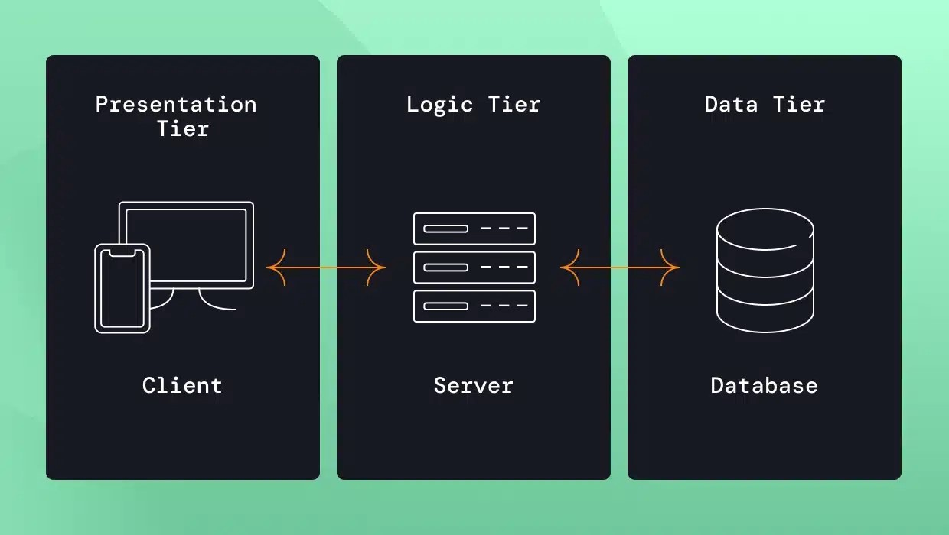

*Figure 3.1: Application Architecture Diagram*

The figure 3.1, represents a three-tier architecture consisting of the Presentation Layer, Application Layer, and Database Layer, all interconnected through secure APIs to ensure seamless and secure communication.

### **3.8.2 Use Case Diagram**

**The e-commerce system involves three main actors: Customer, Admin, and Delivery Agent.**

1. **The Customer actor can perform the following actions; Register/Login, Browse Products, Add to Cart, Place Order, Select Payment Method, Review/Modify Order, Track Order Status** and **Cancel Order.**
2. **Admin actor is responsible for the following actions; Manage Products, Verify POD Orders, Update Order Status,** and **Generate Reports.**
3. **Delivery Agent actor can perform the following actions including, View Assigned Orders, Confirm Delivery Report Issues.**

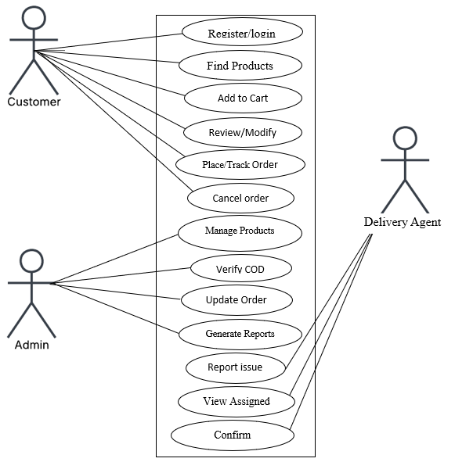

*Figure 3.2: Use-case diagram*

### **3.8.3 Activity Diagram**

An Activity Diagram for an e-commerce website provides a visual representation of the sequential flow of user actions and system processes. However, it illustrates the progression of activities, including start and end states, decision points and parallel operations.

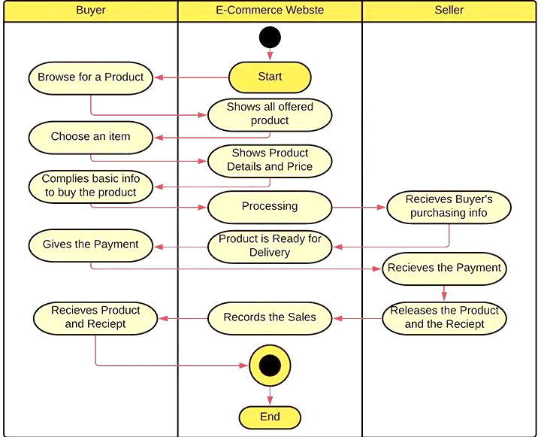

*Figure 3.3: Activity diagram*

### 3.8.4 Dataflow Diagram (DFD)

A Data Flow Diagram for an e-commerce website depicts the flow of data within the system. However, it outlines how data is exchanged between external entities, internal processes, and data storage components, providing a clear view of system interactions and data movement.

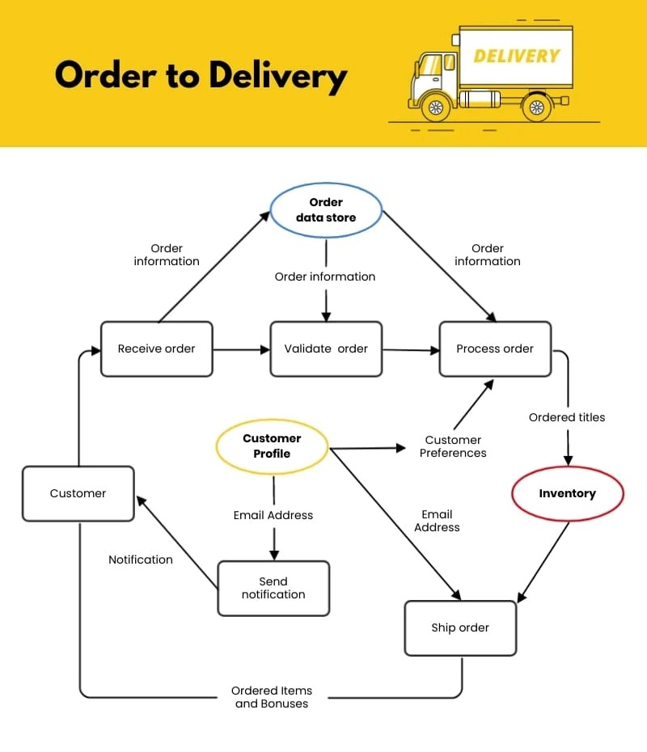

*Figure 3.4: Dataflow Diagram*

### 3.8.5 Control Flow Diagram

A Control Flow Diagram for an e-commerce website is a visual representation that illustrates how data moves through the system. It shows how information is exchanged between external entities, internal processes, and data stores

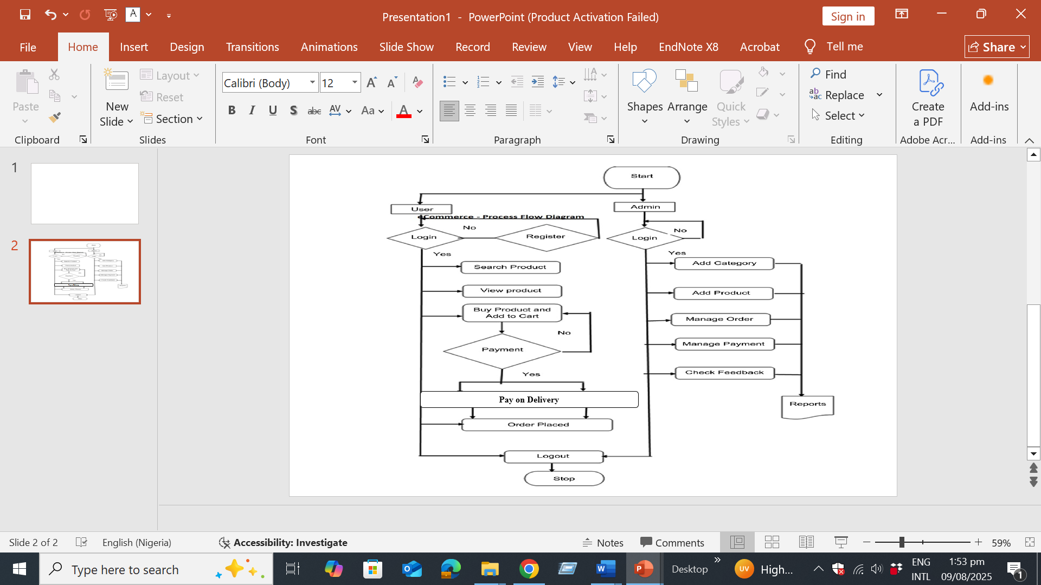

*Figure 3.5: Control flow diagram*

3.8.6 Entity-Relationship Diagram (ERD)

An ERD for an e-commerce website is a graphic model that defines the system's data structure by illustrating the key entities (such as users, products, orders, and payments) and the relationships between them.

However, the relationships in the e-commerce system are as follows: A single User can place multiple Orders, representing a One-to-Many relationship between User and Order. Additionally, each Order can contain multiple Products, and each Product can be part of multiple Orders, forming a Many-to-Many relationship between Order and Product. This many-to-many relationship is typically managed through an intermediary table, such as Order Details.

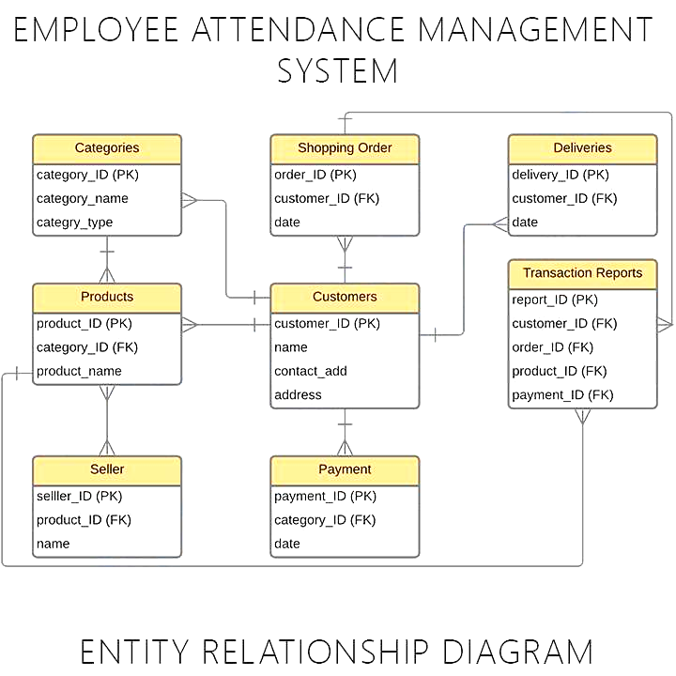

*Figure 3.6: Entity Relationship Diagram*

### **3.9 Summary**

This chapter outlined the complete methodology, requirements, and design for the Order Review E-Commerce System. By adopting an Agile methodology and selecting a lightweight yet powerful technology stack (PHP and SQLite).

The proposed model leverages interviews and observation to address gaps in existing e-commerce systems, with a focus on flexible order review and secure POD.

The functional and non-functional requirements, along with a comprehensive set of design diagrams, provide a clear and actionable blueprint. This will guide the implementation and testing phases described in the subsequent chapter, ensuring the product aligns with the project's core objectives.

# CHAPTER FOUR

## 4.1 Overview

## 4.2 Main Features

## 4.3 Implementation Problems

## 4.4 Overcoming Implementation Problems

## 4.5 Testing

## 4.6 User Guide

## 4.6.1 Homepage

The homepage for the design subme consists of the following features; Products, Cart, My Orders, register, all categories and the Search tabs, as presented in Figure 4.1.

The functions of each of these tabs are hereby explained in the succeeding subsections that follows.

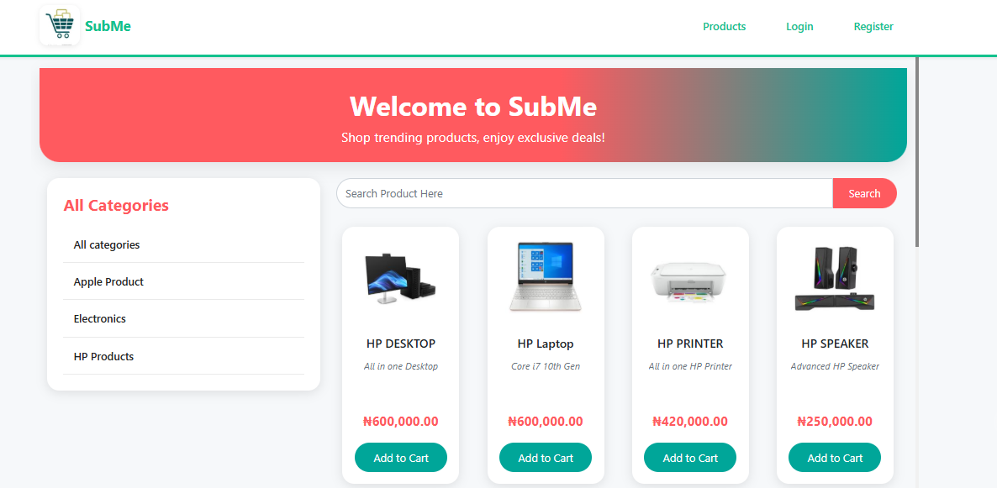

**Figure 4.6.1** Homepage

## 4.6.2 The Register Tab

The register tab presented in Figure 4.2, enables new clients/user who will like to make use of the Subme platform for purchase to register first, thereafter, the client/user can explore the full features of Subme.

New client/user need to provide the following details to register on the Subme platform; full name, username, email, password, contact and address. Thereafter, the new client/user can click on create account for such client/user to become active.

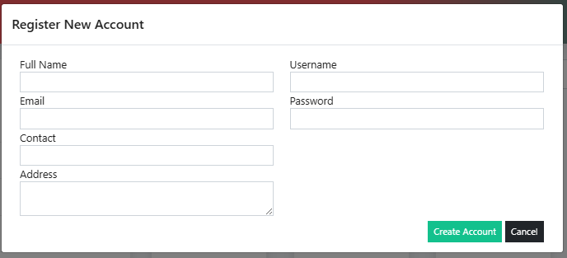

**Figure 4.6.2** Register Tab

A successful registered client/user will now need to provide login details before he/she can now login to Subme platform, Figure 4.3 presents the interface credential Login page for client/user to provide login details, such as username and password before the client/user can now click on Login to get access.

## 4.6.3 Login Welcome Page

The Login Welcome page presented in Figure 4.4, compose of the following features; the registered tab now changed to the name of the registered new client/user with the “Hello” word attached to the client/user name. The client/user can now have access to view, select, add and make order of products.



**Figure 4.6.3** Credential Login Page

### 4.6.4 Add to cart

The Add to Cart is a feature that enable registered client/user to select product(s) of choose and add to cart, for forward onward delivery. In this interface, product name can be view, alongside the specification as well as the cost. After the registered client/user click on Add to Cart, a confirmation popup appears and then the registered client/user can click on ok. Figure 4.5 present the Add to Cart interface.



**Figure 4.6.4** Login Welcome Page

### 4.6.5 Cart Interface

The Cart interface presented in Figure 4.6 is the feature that shows product(s) that have been selected and added to the cart by the registered client/user. The number of products ordered can be seen displayed at the Cart tab, of which from the Figure 4.6, it can be seen as 1, the amount of the product can also be seen. The registered client/user can now proceed to click on checkout, which servs as the final confirmation of the ordered product, registered client/user still have the option of deleting the product using the delete icon tab, if such client/user no longer wish to proceed with the ordered product.

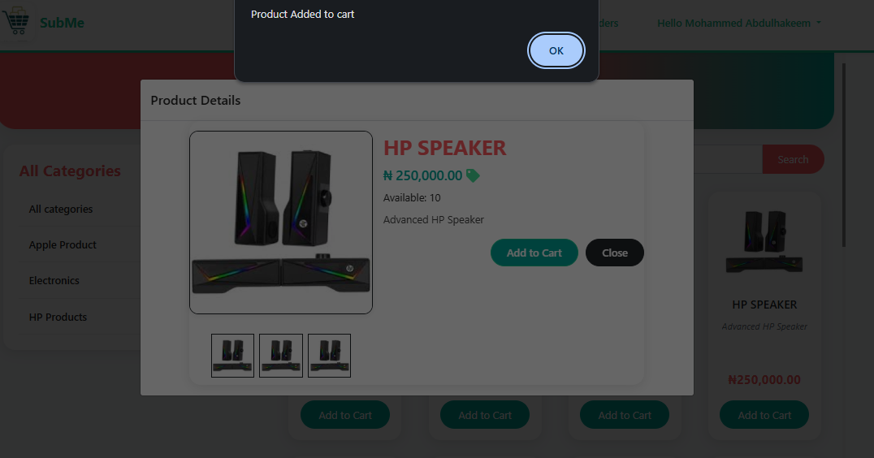

**Figure 4.6.5** Add to Cart Interface

### 4.6.6 Cart Interface

The Cart interface presented in Figure 4.6 is the feature that shows product(s) that have been selected and added to the cart by the registered client/user. The number of products ordered can be seen displayed at the Cart tab, of which from the Figure 4.6, it can be seen as 1, the amount of the product can also be seen. The registered client/user can now proceed to click on checkout, which servs as the final confirmation of the ordered product, registered client/user still have the option of deleting the product using the delete icon tab, if such client/user no longer wish to proceed with the ordered product.

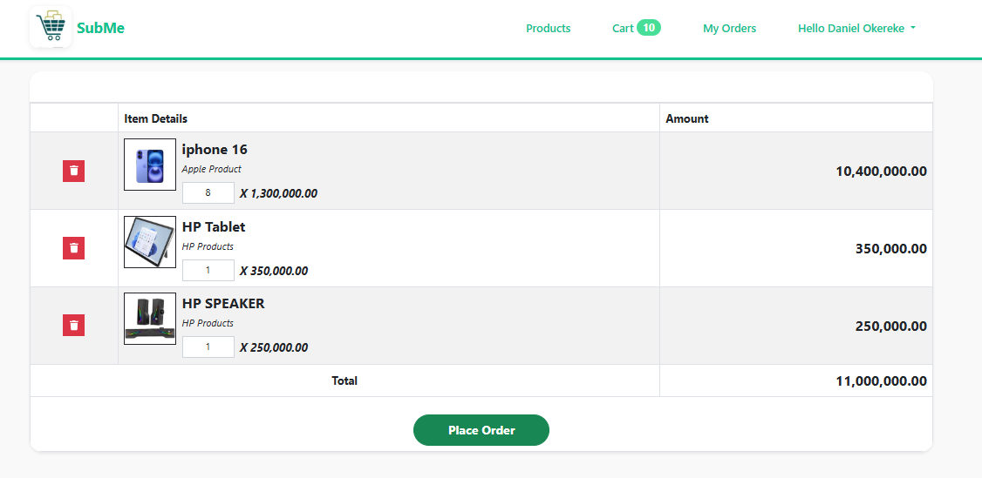

**Figure 4.6.6** Add to Cart interface

### **4.6.7** Checkout Interface

The Checkout interface precede the Cart interface have the features of Delivery Location, from which the registered client/user can select where the ordered product can be delivered, and then the Delivery Address Other Information which is the detailed point of locating the registered client/user.

Thereafter, the registered client/user can now click on Place Order or Cancel tab to conclude the Checkout process.

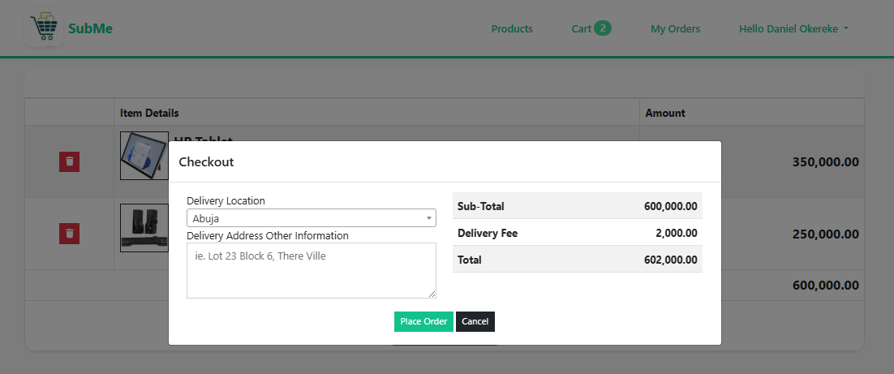

**Figure 4.6.7** Checkout Interface

A successful checkout will lead the registered client/user to the next page “Order successfully placed.” as presented in Figure 4.8, and next is the Order List and Order Detail interface.

## 4.6.8 Oder List Interface

The Order List interface gives the registered client/user a preview of product ordered with details like DateTime Created, Transaction Pode, Customer Name, Items, Total Amount, Status and Action. Giving information about when product order was initiated, the transaction identification number, the registered client/user name, number of products ordered, summary of the product cost, the delivery state and the action which enable the ordered detail view respectively. Figure 4.9 present the Order List interface.

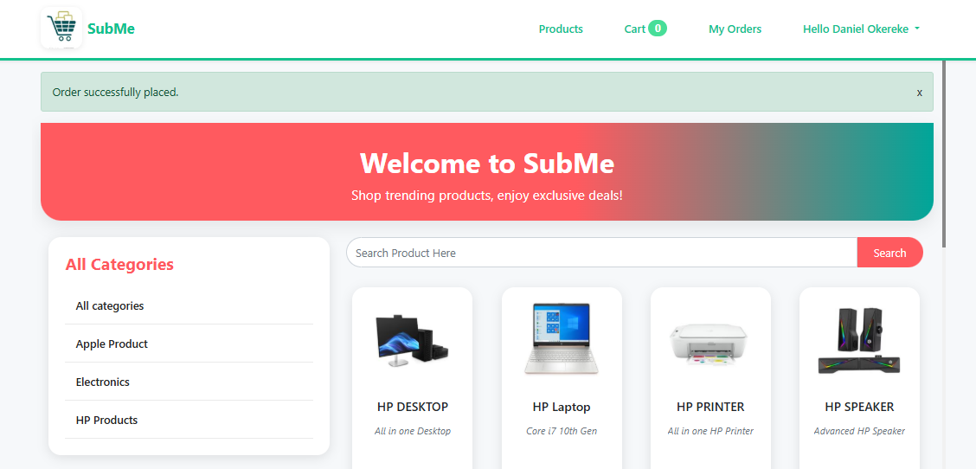

**Figure 4.6.8** Order Successfully Placed Interface

## 4.6.9 Oder List Interface

The Order List interface gives the registered client/user a preview of product ordered with details like DateTime Created, Transaction Pode, Customer Name, Items, Total Amount, Status and Action. Giving information about when product order was initiated, the transaction identification number, the registered client/user name, number of products ordered, summary of the product cost, the delivery state and the action which enable the ordered detail view respectively. Figure 4.9 present the Order List interface.

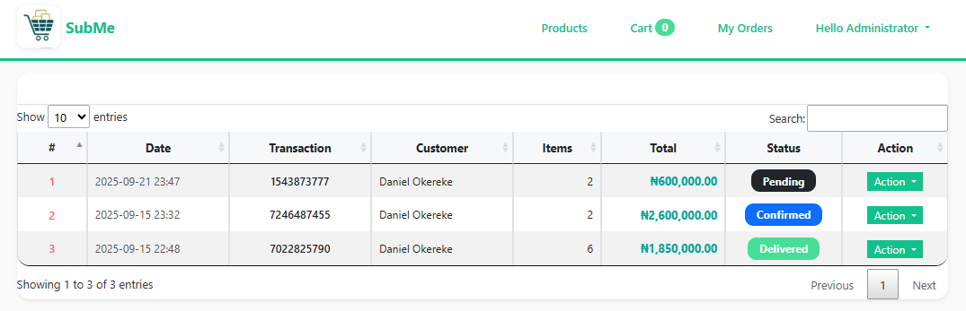

**Figure 4.6.9** Order List Interface

### 4.6.10 The Action Tab

The Action tab which has the View dropdown feature as presented in Figure 10, gives access to the registered client/user full summary of the product (Order Details) been ordered such as the Transaction Pode, the Status, Date Created and Delivery Address as discussed in the preceding subsections. Other information that can be seen are the Quantity (QTY) of ordered product, the specification (Item Details) as well as the cost of the product ordered (Amount). Figure 4.11 depicts the View dropdown detail from the Action tab.



**Figure 4.10.a T**he Action Tab

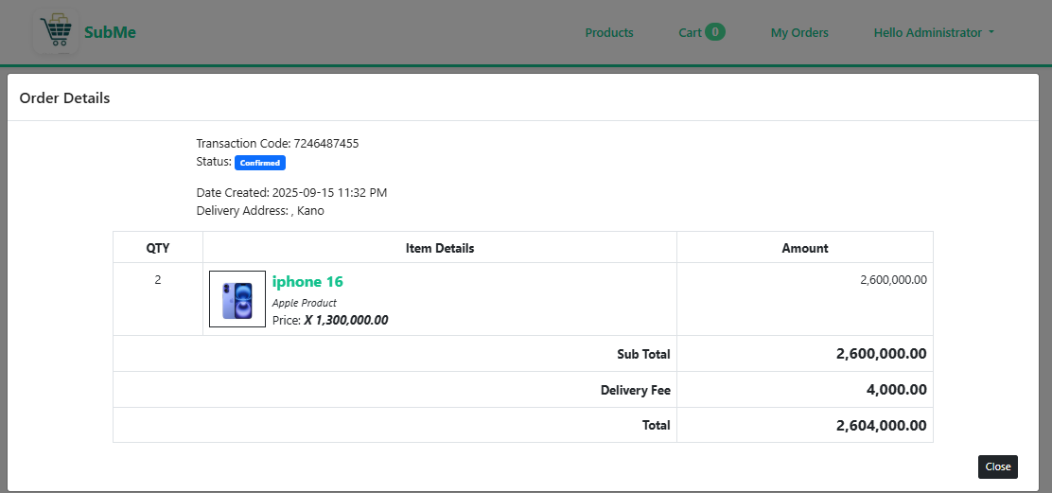

**Figure 4.6.10.b** The View Dropdown Detail from the Action Tab.

### 4.6.11 Manage Account Tab

The Manage Account Tab Figure 4.12 has the dropdown feature of Logout, that is to exit the Subme platform.



**Figure 4.6.11.a** Manage Account Tab

The Manage Account Function allows the registered client/user to update their details such as Full Name, Contact, Email, Address, and Username, as shown in Figure 4.13. The registered client/user can also decide to make changes to his or her password in this interface as well, after all operation are done successfully, the registered client/user can now click on update tab to complete the process of updating his or her information on the Subme platform.

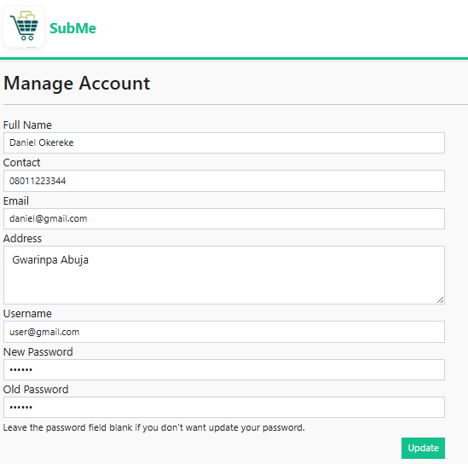

**Figure 4.11.b** The Manage Account Function Interface

**REFERENCE**

Jain, V., Malviya, B. I. N. D. O. O., & Arya, S. A. T. Y. E. N. D. R. A. (2021). An overview of electronic commerce (e-Commerce). Journal of Contemporary Issues in Business and Government, 27(3), 666.

Nasution, M. D. T. P., & Surya, D. H. (2025). Reassessing Payment Methods in E-Commerce: Why Consumers Prefer Cash on Delivery. Journal Business Administration: Entrepreneurship and Creative Industry, 4(1), 22-30.

Rayport, J. F., & Jaworski, B. J. (2003). Introduction to e-commerce. McGraw-Hill, Inc..

Halaweh, M. (2018). Cash on delivery (POD) as an alternative payment method for e-commerce transactions: Analysis and implications. International Journal of Sociotechnology and Knowledge Development (IJSKD), 10(4), 1-12.

Heng, M. S. (2003). Understanding electronic commerce from a historical perspective. Communications of the Association for Information Systems, 12(1), 6.

Okofu, S. N., Bisina, J., Okumoku-Evroro, O., & Akazue, M. I. (2024). CASH ON DELIVERY RISK MITIGATION CMRR MODEL. Journal of the Management Sciences, 61(9), 142-155.

Anjum, S., & Chai, J. (2020). Drivers of payment-on-delivery method of payment in e-commerce shopping: evidence from Pakistan. Sage Open, 10(3), 2158244020917392.

Alfarizi, M., & Sari, R. K. (2023). Adoption of cash on delivery (POD) payment system in shopee marketplace transaction. Procedia Computer Science, 227, 110-118.

Bakar, R., Fauziyah, N., & Rahmat, A. (2025). Do consumers perceive impulsive buying and pain of payment?: E-commerce transactions using pay later, e-wallet, and cash-on-delivery. Gadjah Mada International Journal of Business, 27(1), 31-59.

Kabir, M. A., Saidin, S. Z., & Ahmi, A. (2015, October). Adoption of e-payment systems: a review of literature. In International conference on e-commerce (pp. 112-120).

Panetta, I. C., Leo, S., & Delle Foglie, A. (2023). The development of digital payments–Past, present, and future–From the literature. Research in International Business and Finance, 64, 101855.

Usman P.J (2022) Design and implementation of an e-commerce system.

Hendricks, S., & Mwapwele, S. D. (2024). A systematic literature review on the factors influencing e-commerce adoption in developing countries. Data and Information Management, 8(1), 100045.

Yusuf, A., Gaffar, V., Hurriyati, R., & Wibowo, L. A. (2022, December). E-trust in e-commerce: a systematic literature review. In 3rd Borobudur International Symposium on Humanities and Social Science 2021 (BIS-HSS 2021) (pp. 638-644). Atlantis Press.

Mumu, J. R., Saona, P., Mamun, M. A. A., & Azad, M. A. K. (2022). Is trust gender biased? A bibliometric review of trust in E-commerce. Journal of Internet Commerce, 21(2), 217-245.

Vatrapu, S. R. (2014) Design and Implementation of E-Commerce Site for Online Shopping. All Capstone Projects. 79. <https://opus.govst.edu/capstones/79>

Rihidima, L. V. C., Abdillah, Y., & Rahimah, A. (2022). Adoption of Cash on Delivery Payment Method in E-commerce Shopping: A Value-based Adoption Model Approach. Jurnal Manajemen Teori dan Terapan, 15(3).

Zhang, Y and Wang, R. (2014). Comparison of E-payment of the B2C E-commerce in China from the Security and Trust Perspective. International Journal of Security and Its Applications8(3), 325-338

Achiando, H. A. (2019). E-commerce strategy adoption and performance of micro and small enterprises: A case of private security firms in Nairobi County, Kenya. IOSR Journal of Business and Management, 21(7), 35-64.

Amobi, O.M. (2023). Advantages and disadvantages of cash on delivery in E-commerce. Retrieval from: [https://medium.com/@mariaamobi/advantage-and-disadvantages-of-payment-on-delivery-in-e-commerce-43f7b11962f9](https://medium.com/@mariaamobi/advantage-and-disadvantages-of-cash-on-delivery-in-e-commerce-43f7b11962f9)

Fastercapital, (2023). Simplifying payment: How Cash On Delivery Transforms Online Shopping. Retrieved from: [https://fastercapital.com/content/Simplifying-Payments--How-Payment-on-delivery-Transforms-Online-Shopping.html](https://fastercapital.com/content/Simplifying-Payments--How-Cash-on-Delivery-Transforms-Online-Shopping.html)

Sasu, D. D. (2022). E-commerce in Nigeria –Statistics and Facts. In Statista. <https://www.statista.com/topics/6786/e-commerce-in-nigeria/>.

Okofu, S. N., Bisina, J., Okumoku-Evroro, O., & Akazue, M. I. (2024). Cash on delivery risk mitigation cmrr model. Journal of the Management Sciences, 61(9), 142-155.

Chiejina, C., & Olamide, S. E. (2014). Investigating the Significance of the 'Pay on Delivery' Option in the Emerging Prosperity of the Nigerian e-commerce sector. Journal of Marketing and Management, 5(1), 120.